| **comp** | **fused(# of levels fused)** | | | | | | | | | | | | |
| --- | --- | --- | --- | --- | --- | --- | --- | --- | --- | --- | --- | --- | --- |
| **4** | **5** | **6** | **7** | **8** | **9** | **10** | **11** | **12** | **13** | **14** | **15** | **Total** |
| **Complication=No** | |  | | --- | | 1 | | |  | | --- | | 5 | | |  | | --- | | 10 | | |  | | --- | | 10 | | |  | | --- | | 23 | | |  | | --- | | 68 | | |  | | --- | | 65 | | |  | | --- | | 47 | | |  | | --- | | 48 | | |  | | --- | | 32 | | |  | | --- | | 3 | | |  | | --- | | 1 | | |  | | --- | | 313 | |
| **Complication=Yes** | |  | | --- | | 0 | | 0.0% | | |  | | --- | | 0 | | 0.0% | | |  | | --- | | 1 | | 9.1% | | |  | | --- | | 1 | | 9.1% | | |  | | --- | | 3 | | 11.5% | | |  | | --- | | 8 | | 10.5% | | |  | | --- | | 11 | | 14.5% | | |  | | --- | | 8 | | 14.6% | | |  | | --- | | 8 | | 14.3% | | |  | | --- | | 9 | | 22.0% | | |  | | --- | | 2 | | 40.0% | | |  | | --- | | 0 | | 0.0% | | |  | | --- | | 51 | | 14.0% | |
| **Total** | |  | | --- | | 1 | | |  | | --- | | 5 | | |  | | --- | | 11 | | |  | | --- | | 11 | | |  | | --- | | 26 | | |  | | --- | | 76 | | |  | | --- | | 76 | | |  | | --- | | 55 | | |  | | --- | | 56 | | |  | | --- | | 41 | | |  | | --- | | 5 | | |  | | --- | | 1 | | |  | | --- | | 364 | |

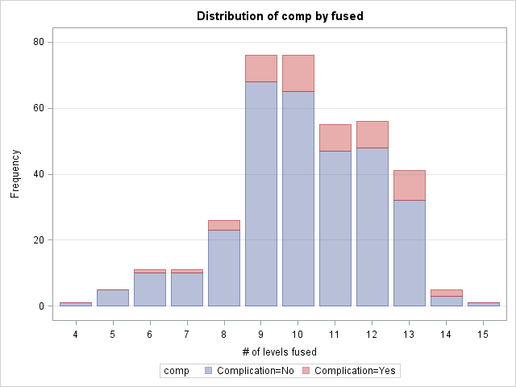

| **Cochran-Armitage Trend Test** | |
| --- | --- |
| **Statistic (Z)** | -2.1103 |
| **One-sided Pr < Z** | 0.0174 |
| **Two-sided Pr > |Z|** | 0.0348 |

The p value (p=0.0174) tells that complication rates increase as number of level fused increase (see below for the linear regression for complication rates vs Number of Fused)

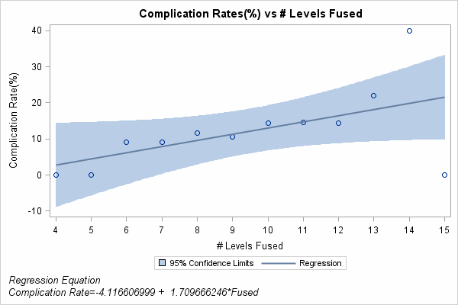

R Square=0.31